*Cryptography*

*“Ejercicio DES*

**Grupo:** 3CM13

**Integrantes:**

* CHACON INOSTROSA JAIME ENRIQUE.
* RAMÍREZ OLVERA GUILLERMO.
* SÁNCHEZ MÉNDEZ EDMUNDO JOSUE.
* BERNAL RAMIREZ ANDRE
* CEDILLO HERNANDEZ JUAN DANIEL
* COVARRUBIAS SANCHEZ DANIEL

**Ejercicio DES**

**Instrucciones**

1. Let M= 11111….1111 and K=1111...1111 be the DES key. Show the output of the Sbox after the first round.

1. Let M= 0000...000 and K=1111…111 be the DES key. Show the output of the Sbox after the first round.

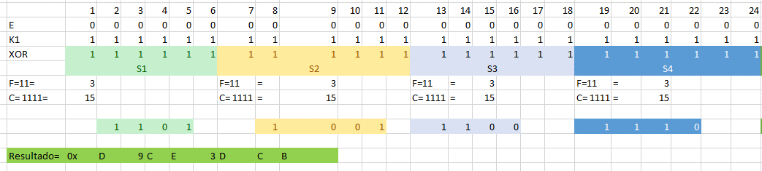

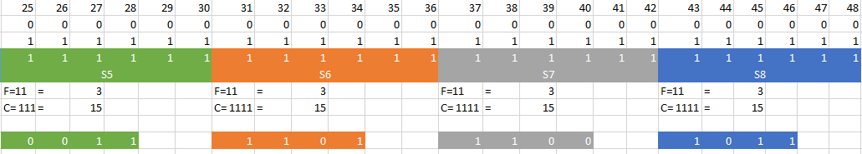

|  |  |  |  |  |  |  |  |  |  |  |  |  |  |  |  |  |  |  |  |  |  |  |  |  |  |  |  |  |  |  |  |  |  |
| --- | --- | --- | --- | --- | --- | --- | --- | --- | --- | --- | --- | --- | --- | --- | --- | --- | --- | --- | --- | --- | --- | --- | --- | --- | --- | --- | --- | --- | --- | --- | --- | --- | --- |
| Let Mix(p)   |  |  |  |  |  |  |  |  | | --- | --- | --- | --- | --- | --- | --- | --- | | 13 | 3 | 2 | 15 | 5 | 10 | 7 | 9 | | 16 | 1 | 14 | 4 | 12 | 6 | 11 | 8 | | Find the inverse Mix   |  |  |  |  |  |  |  |  | | --- | --- | --- | --- | --- | --- | --- | --- | | 10 | 3 | 2 | 12 | 5 | 14 | 7 | 16 | | 8 | 6 | 15 | 13 | 1 | 11 | 4 | 9 | |

1. Show that in DES the S-boxes are nonlinear. Let the input to the S-box

X1 = absolu

X2= crimin

a)Find S3(x1) XOR S3(x2)

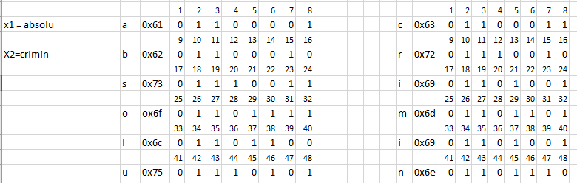

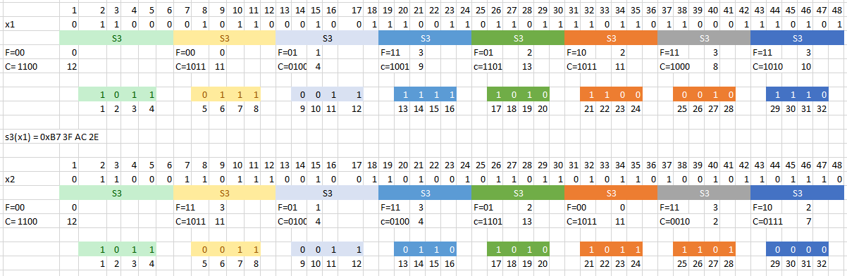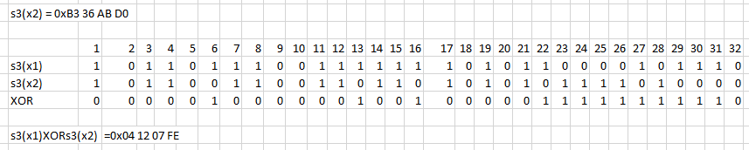

b)Find S3(x1 XOR x2)

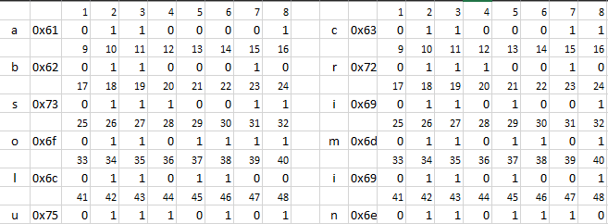

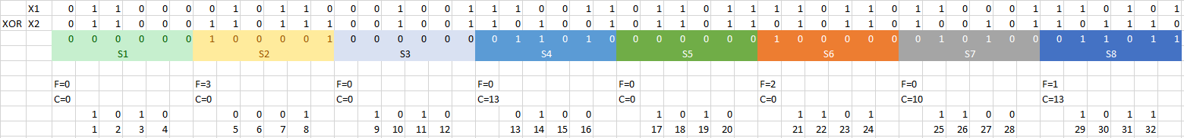

1. If the initial Key= **academic** calculate the K2 Using DES.

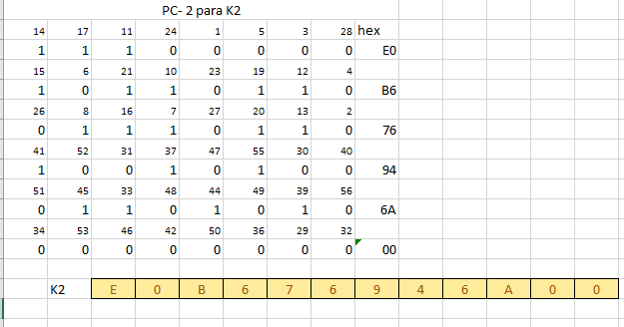

1. If the initial Key= **academic** calculate the K6 Using DES.

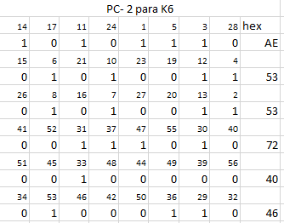



**Deadline**

[Capte la atención de los lectores mediante una cita importante extraída del documento o utilice este espacio para resaltar un punto clave. Para colocar el cuadro de texto en cualquier lugar de la página, solo tiene que arrastrarlo.]